**Bank Loan Analysis SQL Query Document**

**A. Bank Loan Summary:**

**Key Performance Indicators (KPIs)**

**1. Total Loan Applications:**

select COUNT(id) as [Total Applications] from Bank_loan_data



**MTD Applications:**

select COUNT(id) as [Total Applications_MTD] from Bank_loan_data

where month(issue_date) = 12 and YEAR(issue_date) = 2021;

go



**Month-over-month Applications:**

select COUNT(id) as [Total_Applications_Previous_month] from Bank_loan_data

where YEAR(issue_date) = 2021 and MONTH(issue_date)= 11;

go



**2. Total Funded Amount:**

select format(SUM(loan_amount),'$ #,##0','en-US') as [Total Funded Amount] from Bank_loan_data

go



**Total Funded Amount MTD:**

select format(SUM(loan_amount),'$ #,##0','en-US') as [Total Funded Amount_MTD] from Bank_loan_data

where MONTH(issue_date) = 12 and YEAR(issue_date) = 2021;

go



**Total Funded Amount MoM:**

SELECT FORMAT(SUM(loan_amount), '$ #,##0', 'en-US') AS [Total Funded Amount (Previous_month)]

FROM Bank_loan_data

WHERE MONTH(issue_date) = 11 AND YEAR(issue_date) = 2021;



**3. Total Amount Received:**

select FORMAT(sum(total_payment),'$ #,##0','en-US') as [Total Payment Recieved ] from bank_loan_data

go



**Total Amount received MTD :**

select FORMAT(sum(total_payment),'$ #,##0','en-US') as [Total Payment Recieved ] from bank_loan_data

where YEAR(issue_date) = 2021 and MONTH(issue_date) = 12

go



**Total Amount received MoM :**

select FORMAT(sum(total_payment),'$ #,##0','en-US') as [Total Payment Recieved ] from bank_loan_data

where YEAR(issue_date) = 2021 and MONTH(issue_date) = 11

go



**4. Average Interest Rate:**

select ROUND(AVG(int_rate),4)*100 as [Average Interest Rate] from bank_loan_data

go



**Average Interest Rate MTD:**

select ROUND(AVG(int_rate),4)*100as [Average Interest Rate MTD] from bank_loan_data

where YEAR(issue_date) = 2021 and MONTH(issue_date) = 12

go



**Average Interest Rate MoM:**

select ROUND(AVG(int_rate),4)*100 as [Average Interest Rate MoM] from bank_loan_data

where YEAR(issue_date) = 2021 and MONTH(issue_date) = 11

go



**5. Average Debt to interest ratio:**

select ROUND(AVG(dti),4)*100 as [Average DTI] from bank_loan_data

go



**Average Debt to interest ratio MTD:**

select ROUND(AVG(dti),4)*100 as [Average DTI MTD] from bank_loan_data

where YEAR(issue_date) = 2021 and MONTH(issue_date) = 12

go



**Average Debt to interest ratio MoM:**

select ROUND(AVG(dti),4)*100 as [Average DTI MoM] from bank_loan_data

where YEAR(issue_date) = 2021 and MONTH(issue_date) = 11

go



**B. Good Loan Vs. Bad Loan KPIs:**

**Distinct Values in Loan Status:**

Select distinct loan_status from Bank_loan_data

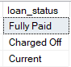

**1. Good Loan KPIs:**

**Good Loan Applications Percentage :**

select ROUND(COUNT(case when loan_status ='Fully Paid' OR loan_status ='Current' then id end)*100 /count(id),4) as [Good Loan Application Percentage]

from Bank_loan_data;

go



**Good laon Applications**

select COUNT(id) as [Total Good Laon Applications] from Bank_loan_data

where loan_status= 'Fully Paid' or loan_status = 'Current'

go



**Good Loan Funded Amount:**

select Format((SUM(loan_amount)),'$ #,##0', 'es-Us') as [Total Amount Disburshed for Good Loans] from Bank_loan_data

where loan_status= 'Fully Paid' or loan_status = 'Current'

go



**Good Loan Total Received Amount:**

select Format((SUM(loan_amount)),'$ #,##0', 'es-Us') as [Total Amount Received for Good Loans] from Bank_loan_data

where loan_status= 'Fully Paid' or loan_status = 'Current'

go



**2. Bad Loans KPIs:**

**Bad Loan Application Percentage:**

select ROUND(COUNT(case when loan_status ='Charged Off' then id end)*100 /count(id),4) as [Bad Loan Application Percentage]

from Bank_loan_data;

go



**Bad laon Applications:**

select COUNT(id) as [Total Bad Laon Applications] from Bank_loan_data

where loan_status= 'Charged Off';

go



**Bad Loan Funded Amount:**

select Format((SUM(loan_amount)),'$ #,##0', 'es-Us') as [Total Amount Disbursed for Bad Loans] from Bank_loan_data

where loan_status= 'Charged Off';

go



**Bad Loan Total Received Amount:**

select Format((SUM(loan_amount)),'$ #,##0', 'es-Us') as [Total Amount Received for Bad Loans] from Bank_loan_data

where loan_status= 'Charged Off';

go



**C. Loan Status Overview:**

**Loan Status Analysis:**

SELECT

loan_status,

COUNT(id) AS [Total Loan Application],

SUM(total_payment) AS [Total Amount Received],

SUM(loan_amount) AS [Total Amount Disbursed],

AVG(int_rate * 100) AS [Interest Rate],

AVG(dti * 100) AS DTI

FROM

bank_loan_data

GROUP BY

loan_status

go

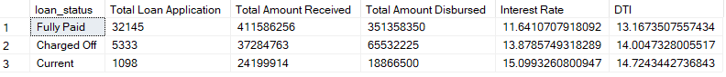

**MTD Loan Status Analysis:**

SELECT

loan_status,

SUM(total_payment) AS [MTD Total Amount Received],

SUM(loan_amount) AS [MTD Total Amount Disbursed]

FROM bank_loan_data

WHERE MONTH(issue_date) = 12

GROUP BY loan_status

Go

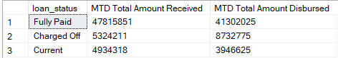

**D. BANK LOAN REPORT/ OVERVIEW:**

**Monthly overview.**

SELECT

MONTH(issue_date) AS [Month Number],

DATENAME(MONTH, issue_date) AS [Month name],

COUNT(id) AS [Total Loan Applications],

SUM(loan_amount) AS [Total Funded Amount],

SUM(total_payment) AS [Total Amount Received]

FROM bank_loan_data

GROUP BY MONTH(issue_date), DATENAME(MONTH, issue_date)

ORDER BY MONTH(issue_date)

Go

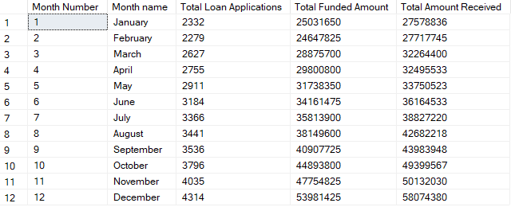

**Statewise Overview:**

SELECT

address_state AS State,

COUNT(id) AS [Total Loan Applications],

SUM(loan_amount) AS [Total Funded Amount],

SUM(total_payment) AS [Total Amount Received]

FROM bank_loan_data

GROUP BY address_state

ORDER BY address_state

go

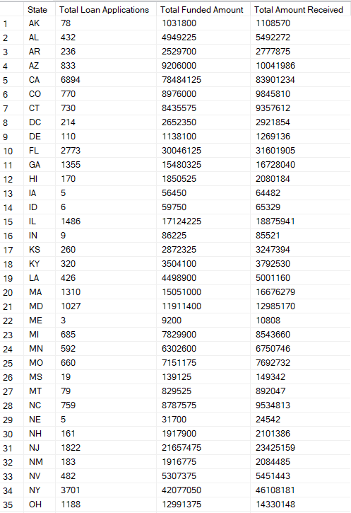

**Term wise overview:**

SELECT

term AS Term,

COUNT(id) AS [Total Loan Applications],

SUM(loan_amount) AS [Total Funded Amount],

SUM(total_payment) AS [Total Amount Received]

FROM bank_loan_data

GROUP BY term

ORDER BY term

go

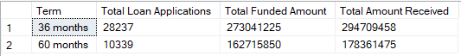

**Employee Length wise Overview:**

SELECT

emp_length AS [Employee Length],

COUNT(id) AS [Total Loan Applications],

SUM(loan_amount) AS [Total Funded Amount],

SUM(total_payment) AS [Total Amount Received]

FROM bank_loan_data

GROUP BY emp_length

ORDER BY emp_length

Go

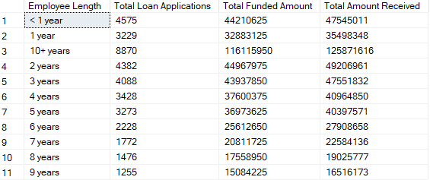

**Purpose wise Overview:**

SELECT

purpose AS PURPOSE,

COUNT(id) AS [Total Loan Applications],

SUM(loan_amount) AS [Total Funded Amount],

SUM(total_payment) AS [Total Amount Received]

FROM bank_loan_data

GROUP BY purpose

ORDER BY purpose

go

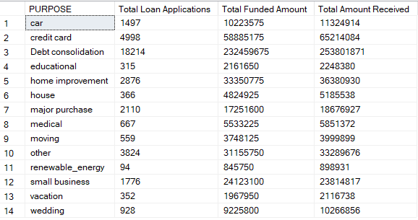

**Homeownership Overview:**

SELECT

home_ownership AS Home_Ownership,

COUNT(id) AS [Total Loan Applications],

SUM(loan_amount) AS [Total Funded Amount],

SUM(total_payment) AS [Total Amount Received]

FROM bank_loan_data

GROUP BY home_ownership

ORDER BY home_ownership

go

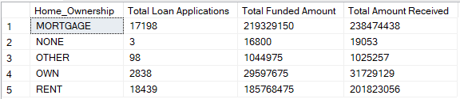

*Note: This document has been created to validate the Tableau dashboard. The project is intended for learning purposes and is inspired by Data Tutorials.*